22nd /May /2021

JOSEPH’S STORY

# *Timeline*

By name is Joseph Owaga born on 08th/Nov/2002 of Mr and Mrs Owaga both Kenyan citizens by birth

I was brought up in a family of 3boys and a girl by names:

George, Paul, Brian and Silvia

## EDUCATION BACKGROUND

### Being brought up in Kenya I went through the 8-4-4education system where :

### I began my schooling in the year 2008 and sat for my final primary paper in 2016 after the eight years of studies and scored a grade of B.

### I then attended high school for 4 years then in early months of 2021 I sat for KCSE and also scored a grade of B

### The examination was to be done on Nov of 2020 but due to the covid 19 pandemic it never happened as scheduled

### Currently I am indoors doing little of computer work as I wait to proceed to the University for the next level of my career studies

# 2.HOBBIES AND INTERESTS

* I majorly read novels and short stories during my free time to come up with my summary of understanding about the book
* 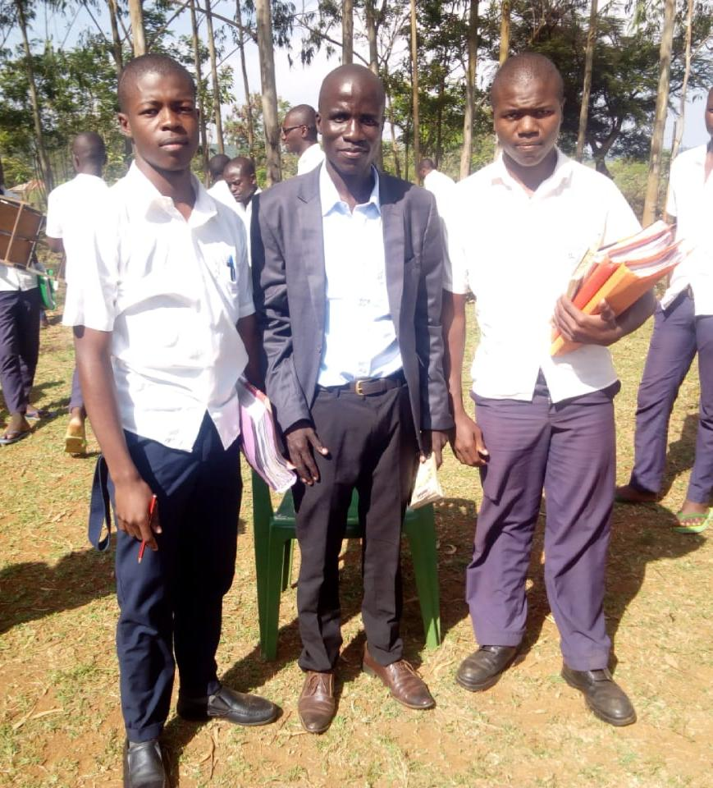For body fitness I love football
* 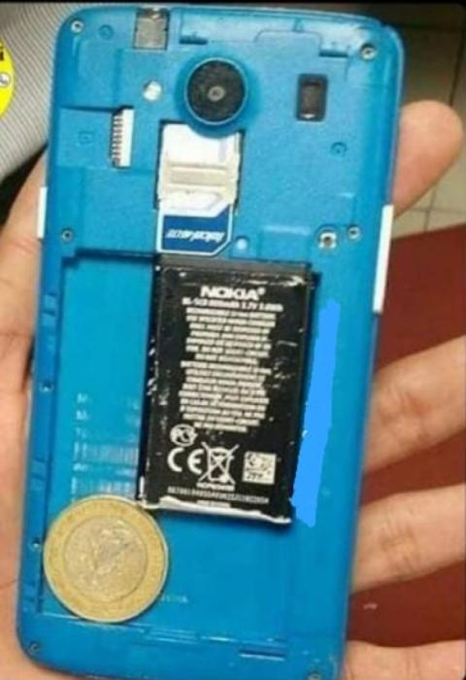I also like coming up with new ideas
* 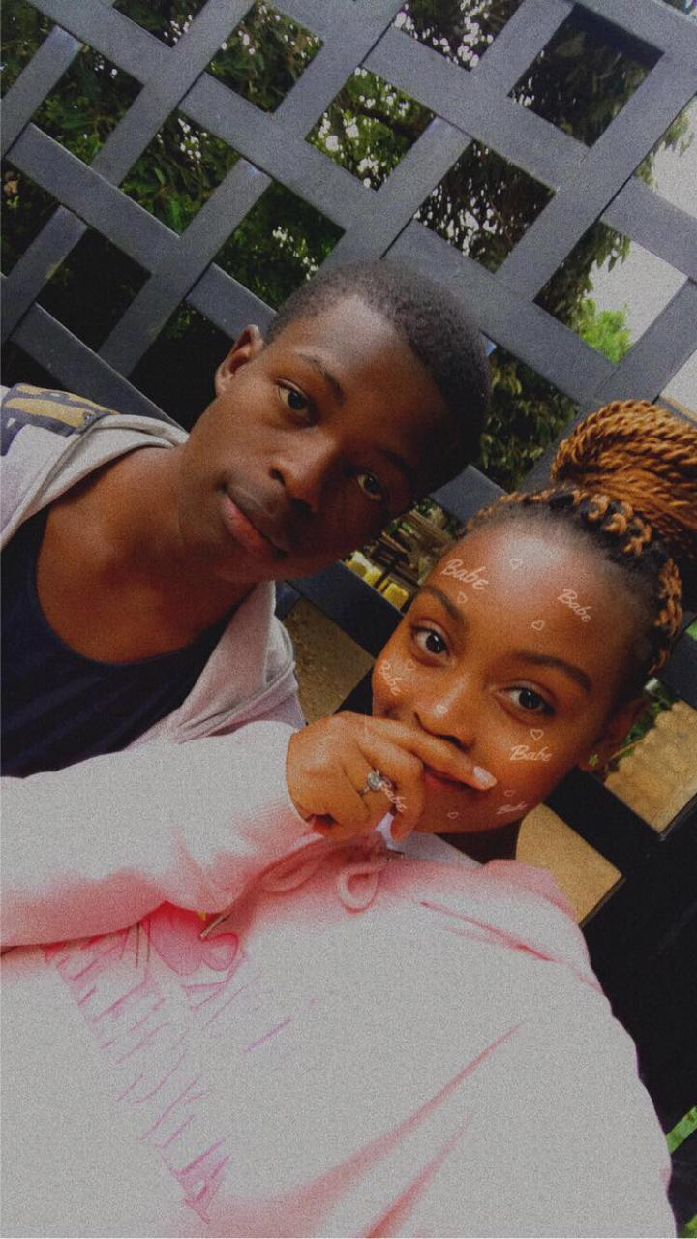Finally I like having fun hunging up with friends